Week of SEND 2021
Changing Places
Presentation by - Karen
Changing Places toilets are different to standard disabled toilets with extra features and more space to meet additional needs. Each Changing Places toilet provides:
● A height adjustable adult-sized changing bench (wall-mounted or free-standing)
● A tracking hoist system
● Adequate space in the changing area for the disabled person and up to two carers (Minimum of 3m x 4m/ 12m2 in new builds and 3m x 3m/9m2 in existing buildings)
● Centrally placed toilet with room either side for carers
Changing Places toilets have sufficient space for the disabled person and their carer thus allowing carers themselves to use the toilet, something which they cannot do in a standard disabled toilets.
Email:- K.Hoe@musculardystrophyuk.org. Tel:- 07701373565
Community Dental Services
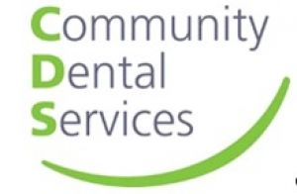Presentation by - Gina
Community Dental Services in Lincolnshire is a specialist dental provider for residents within the County (excluding North and North East Lincolnshire) with significant medical, physical or mental health disabilities, or people with severe dental anxiety. We are a referral only service, and our acceptance criteria and referral form can be found on our website.
They pride themselves on providing high quality care and treatment for children and adults whose dental care cannot be managed by a General Dental Practitioner. They accept referrals from all healthcare providers, however any referrals for dental anxiety reasons must come from a Dentist.
The Oral Health Improvement Team are part of the service co-ordinating, facilitating and supporting a range of evidence-based interventions to reduce oral health inequalities and promote better oral health.
Oral health is everyone’s responsibility; therefore, training is available to health and non- health professionals.
Sessions are tailored to meet the requirements of specific teams e.g. health visiting, teachers and many voluntary sector areas.
Email:- ohimp.lincolnshire@cds-cic.nhs.uk Web:- www.communitydentalservices.co.uk
LCC Local Offer
Presentation by - Kate
The Local Offer is part of the Special Educational Needs and Disability (SEND) reforms from the Children and Families Act 2014.
There are two main purposes for the Local Offer:
To improve information about services and provision available for families, children and young people with Special Educational Needs and Disabilities, and to make it easier for all families to find this information by making it available in one place.
That by working directly with families, children and young people on developing the Local Offer, Local Authorities and Health partners can improve provision.
Lincolnshire’s Local Offer includes leisure and activity providers, health and care services, education providers and support groups.
The Local Offer, as with the rest of the Family Services Directory, is provided to help you find services more easily.
Web:- lincolnshire.fsd.org.uk/kb5/lincs/fsd/localoffer.page?familychannel=2
LCC Specialist Teaching Team - ECLIPS speech and language specialist teachers – plus Dyslexia Outreach specialist teachers
Presentation by - Trish
ECLIPS are part of Lincolnshire County Council's Specialist Teaching Team, they specialise in supporting children and young adults with speech and language difficulties.
They work closely with parents/carers, schools/colleges and other professional agencies such as the NHS Speech and Language Therapy service.
They are keen to promote Makaton training and support options for families and educators. Makaton is an internationally recognised language development programme that supports a multi-modal approach to teaching communication, language and literacy skills.
It can be used to support a wide range of communication and language needs from individuals with profound, moderate or mild learning difficulties, individuals with Developmental Language Disorder, individuals with no or developing speech, individuals with autistic spectrum disorders or sensory impairments to individuals with EAL.
The Dyslexia Outreach specialist teachers are also part of LCC's Specialist Teaching Team and offer advice and support for individuals with Dyslexia.
Email:- STTenquiries@lincolnshire.gov.uk Tel:- 01522 553265
Rett UK
Presentation by - Julie
Rett syndrome is a rare neurological disorder affecting mainly females and very few males. It is present from conception and usually remains undetected until major regression occurs at around one year of age, when children may lose acquired skills and become withdrawn. Genetic but largely not inherited, Rett syndrome is usually caused by a fault on a gene called MECP2 which is found on the X chromosome. People with Rett syndrome have profound and multiple physical and communication disabilities and are totally reliant on others for support throughout their lives.
Rett UK provide free support, advice and resources to anyone affected by Rett syndrome. Amongst their services their Family Support Team offer: help with diagnosis, support groups, advocacy, getting started with communication support and training, regional roadshows, accessing a specialist Rett syndrome clinic, as well as bereavement support.
Email:- support@rettuk.org Tel:- 01582 798 911 Web:- www.rettuk.org

Week of SEND 2021
Early Years Alliance - Best Start Service
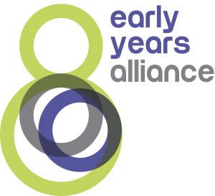Presentation by - Lesley
Early Years Alliance
A leading early years charity delivering the Best Start Children’s and Family Service across the 48 Children’s Centres of Lincolnshire and outreach venues. Offering Early Years and Skills Development support for families; supporting the understanding of children’s learning and development, offering high quality Early Years sessions for families, and supporting parents and carers on their personal pathways to success.
Additionally, providers of certificated ‘Family Learning’ for families, and sector workshops for practitioners, delivered by experienced and qualified tutors.
Email:- lincolnshire@eyalliance.org.uk
LCC Children's Health
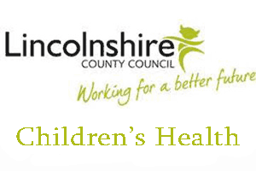Presentation by - Liz - Paediatric Incontinence
We are Children's Health and we consist of a team of Health Visitors and CYPN'S (Children and Young people's nurses).
We support parents in inclusion by working with SENCO'S, ESCO'S and providing continence products.
LCC Children's Health
Presentation by - Samantha - Health visiting team
We are Children's Health and we consist of a team of Health Visitors and CYPN'S (Children and Young people's nurses).
We support parents in inclusion by working with SENCO'S, ESCO'S and providing continence products.
LCC Childrens Centres
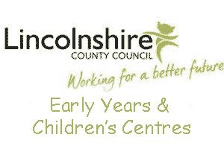Presentation by - Richard
Children's Centres offer child and family health services, and advice and information for families. They provide stay and play sessions to support children's development, including groups specifically for Early Years children with SEND. Some centres have bookable sensory rooms which can be accessed on a 1:1 basis for parent/carers and children.
In addition, Children's Centres can provide adult learning and volunteering opportunities, and support for parents on a wide range of issues, including the delivery of parenting programmes.
Children’s Centre Skills Development Officer
Offers friendly and personalised information, to identify skills gaps and support parents to enter into learning, volunteering, apprenticeships and employment.
Also provides individual support by tailoring a personal development plan for individual parents/carers, identifying next steps and supporting them to achieve their goals.
Email:- Katie.weaver@eyalliance.org.uk (Skills development officer) Tel:- 01522 552752 Mob:- 07739362077 (SDO)
LCC Early Years & ChildCare Support
Presentation by - Carol
Early Years Specialist Teachers based in localities provide ongoing support for Childminders, Nurseries and Pre Schools /EY SENCOs who have children with SEND.
Early Years SENCOs can also request support via the Early Years and Childcare website.
Early Years and Childcare support deliver a range of training opportunities such as networks and SENCO training for Early Years Providers to ensure that they meet the requirements of the SEND Code of Practice.
Early Years Specialist Teachers also target their support for Children who are looked after, Vulnerable children on a plan who are behind age related attainment, Children at risk of exclusion, Transition support.
Early Years Specialist teachers are based under the Early Help Locality Teams so can link with Health and Social care.
Tel:- 01522 552752
LCC Portage Service - Spalding & District
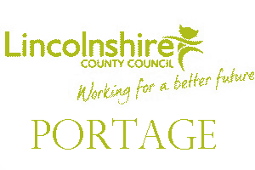Presentation by - Karen
Portage is a scheme for teaching pre-school children with special educational needs, new and useful skills in their own homes. The basis of Portage is weekly home visiting, with the Portage worker and the parents/carers working together.
The Portage Home Visitor works with parents in their home because young children initially learn best in the security of their own home with the people who know them. The Portage Home Visitor visits the family at home weekly or fortnightly and plans activities with the parents/carers. Every activity is written down, as is every success. Each child’s progress is reviewed at least every three months and the need for ongoing Portage is discussed.
Portage is a home visiting educational service for pre-school children with special educational needs. These may be pre-school children who have learning difficulties, delays in their development and/or physical difficulties. The Portage Teams aim to help families by working with them in their home, helping them to meet the needs of their child.
Children can be referred from birth by parents/carers or any agency involved with the child such as health visitors, general practitioners, speech and language therapists, occupational therapists, educational psychologists, physiotherapists, paediatricians etc.
Each area has its own portage team.
Email:- karen.kitney@garth.lincs.sch.uk Tel:- 07989 362684
Web:- www.spaldingspecialschools.co.uk

Week of SEND 2021
The Sleep Charity
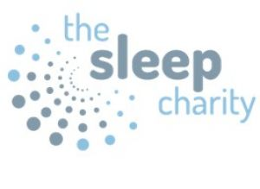Presentation by - Claire
Sleep deprivation can have a serious impact on emotional, physical and emotional health. The Sleep Charity offer a range of support and services from working directly with families who are approaching crisis point to delivering training to professionals
They help families on a one to one basis within the Lincolnshire area, supporting them and their children to get better sleep. They do this by looking at aspects such as bedtime routines, helping to recognise sleep issues, the causes of those issues and build in strategies to help aid better sleep.
Contact(s):- Claire / Email:- claire@thesleepcharity.org.uk Mob:- 07568 052300 Web:- www.thesleepcharity.org.uk

Week of SEND 2021
Bid Services Lincolnshire
Presentation by - Jorja
Are a charity that work in partnership with children, young people, adults and their families and carers. They support people who are deaf, hard of hearing, visually impaired or have a dual sensory loss.
Bid Services run activities throughout Lincolnshire called Chance to Meets for families with children with sensory impairments. These events given families an opportunity to meet, socialise and share experiences. Activities include sports events, bowling, music sessions and sensory activities at local parks and nature reserves and much more!
They also have a specialist care and support service to help children, young people and adults with a sensory loss to maintain their independence and improve their lives. They have a team of support workers trained in Deaf and Visual Awareness, BSL and Deafblind communication and sighted guide.
BID services also has as an employment coach for people with sensory impairment.
Contact(s):- Jorja / Angela (employment coach) Email:- support@bidlincs.org.uk Tel:- 01522 848295 Mob:- 07702939170 & 07783809801 Web:- www.bidlincs.org.uk
Hummingbird Hypnotherapy
Presentation by - Nicole
Nicole Woodcock is a Clinical Hypnotherapist and lecturer in her practice Hummingbird Hypnotherapy. Working with adults and children from the age of 4.
With a background of working in a social care setting for 15 years Nicole now uses clinical hypnotherapy to work with children with additional needs and neuro diversity.
Offering a supportive and relaxed environment for positive therapy.
Teaching young people how their brain works and incorporating psychotherapy with trance relaxation.
Sessions available face to face and online via zoom.
Nicole runs LPCF's "Learning to see the light after Lockdown" sessions.
Contact(s):- Nicole / Web:- www.hummingbirdhypnotherapy.co.uk.
LCC Sensory Education and Support Team
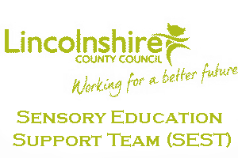Presentation by - Emma
This service is delivered by teachers who have specialist qualification in the education of sensory impaired children and young people.
Experts include teaching assistants working with those with sensory impairment and an educational mobility officer for visually impaired children and young people.
The team is involved from an early stage soon after birth and through the learning journey to independent adulthood.
The team work alongside parents to support the development of their child, then with settings and schools to ensure the child or young person can access the full educational curriculum.
Individual support or advice is available to all children and young people with diagnosed sensory impairment.
Bespoke training is given to schools and settings with children and young people with sensory impairments
Email:- sest@lincolnshire.gov.uk Tel:- 01522 554211
Lincolnshire Down's Syndrome Support Group (LDSSG)
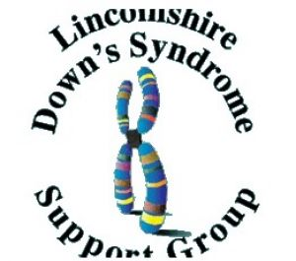Presentation by - Emma
The Lincolnshire Down’s Syndrome Support Group (LDSSG) are a parent-led charity whose principle aim is to enhance the lives of people with Down’s Syndrome and their families in Lincolnshire.
Established in 1983 by a group of parents wishing to offer support and share experiences of parenting a child with Down’s Syndrome, they still hold this value at the heart of our group. They love to welcome new members and regularly hold events where families can gather to offer each other support, advice and most importantly, friendship.
They currently support over 70 families throughout Lincolnshire and see ourselves as one big family joined by a common thread…they all love someone with Down’s Syndrome and value the joy they bring to their lives!
Web:- www.lincsdownsyndrome.org.uk/
Rhubarb theatre
Presentation by - Kirsty & Philip
Rhubarb Theatre create theatrical experiences for any age or ability.
They are very bespoke, and can run a variety of sessions including drama, music, movement and making for your group, interactive storytelling sessions and even online arts sessions.
Their performances (inside and out) are visual, full of music and perfect for families. They also do lots of wonderful walkabout which can add a sprinkle of joy to your outdoor events and festivals.
They are a charity based in Lincolnshire, created to bring arts and joy to anyone who will have them!
Contact(s):- Kirsty & Philip Mead / Email:- info@rhubarbtheatre.co.uk Tel:- 01400 275133 Web:- www.rhubarbtheatre.co.uk

Week of SEND 2021
LCC Specialist Teaching Team - ECLIPS speech and language specialist teachers – plus Dyslexia Outreach specialist teachers
Presentation by - Trish, Laura, Helen, Odette and Karen
ECLIPS are part of Lincolnshire County Council's Specialist Teaching Team, they specialise in supporting children and young adults with speech and language difficulties.
They work closely with parents/carers, schools/colleges and other professional agencies such as the NHS Speech and Language Therapy service.
They are keen to promote Makaton training and support options for families and educators. Makaton is an internationally recognised language development programme that supports a multi-modal approach to teaching communication, language and literacy skills.
It can be used to support a wide range of communication and language needs from individuals with profound, moderate or mild learning difficulties, individuals with Developmental Language Disorder, individuals with no or developing speech, individuals with autistic spectrum disorders or sensory impairments to individuals with EAL.
The Dyslexia Outreach specialist teachers are also part of LCC's Specialist Teaching Team and offer advice and support for individuals with Dyslexia.
Email:- STTenquiries@lincolnshire.gov.uk Tel:- 01522 553265

Week of SEND 2021
Kooth
Presentation by - Richard
Kooth is a digital service available to all 11- 18 yr olds, this extends up to 25 yrs for Care Leavers and those with SEN.
Kooth provides safe, free and anonymous text based 1:1 counselling and youth support. This is available from 12 - 10 pm Mon - Fri and 6 - 10 pm at the weekend, every day of the year
The Kooth platform is available 24/7 and is a safe and supportive online community where children and young people can boost their wellbeing with access to therapeutic content and peer to peer support via our magazine, live forums, static discussion boards, mini activities hub, journaling, goal setting and much more.
Here is the link to the Kooth video https://vimeo.com/318731977/a9f32c87de
Email:- parents@kooth.com Web:- www.kooth.com

Week of SEND 2021
Hil Gibb
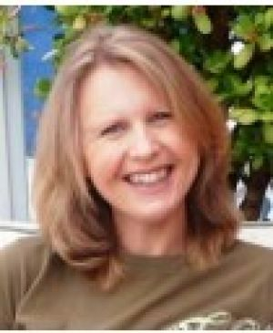Presentation by - Hil
Hil is a successful Master Practitioner and Coach in Neuro Linguistic Programming (NLP), with a Masters Degree in Leadership.
She loves working with a wide range of individuals facing significant, personal challenge as well as groups of varying sizes across business and education.
Hil offers a fresh perspective, bold problem-solving and unorthodox strategies. Her main strengths lie in her ability to connect with people;motivating and developing them to think actively, flexibly and creatively. She relishes new challenges and is committed to adding value to, and facilitating the growth of individuals and teams.
Hil is currently the trainer for LPCF's parents workshops - "waving not drowning".
Email:- Hil@hilgibb.co.uk
LCC Children with Disabilities Social Work Team
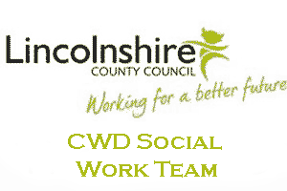Presentation by - Karen
Lincolnshire County Council’s Children with Disabilities Team are part of the Special Education Need and Disability Service.
The social work team provides a statutory service for children and young people with a severe and profound disability.
Services may be available to those that are eligible after being subject of a social care assessment.
Tel:- 01522 782111
LCC Childrens Centres
Presentation by - Katie
Children's Centres offer child and family health services, and advice and information for families. They provide stay and play sessions to support children's development, including groups specifically for Early Years children with SEND. Some centres have bookable sensory rooms which can be accessed on a 1:1 basis for parent/carers and children.
In addition, Children's Centres can provide adult learning and volunteering opportunities, and support for parents on a wide range of issues, including the delivery of parenting programmes.
Children’s Centre Skills Development Officer
Offers friendly and personalised information, to identify skills gaps and support parents to enter into learning, volunteering, apprenticeships and employment.
Also provides individual support by tailoring a personal development plan for individual parents/carers, identifying next steps and supporting them to achieve their goals.
Email:- Katie.weaver@eyalliance.org.uk (Skills development officer) Tel:- 01522 552752 Mob:- 07739362077 (SDO)
Lincolnshire Fire and Rescue
Presentation by - Annie
Lincolnshire fire and rescue are able to give advice on home fire safety, evacuation plans and the fire setting intervention scheme. The fire service may also be able to offer a free safe and well check in your home which may include the fitting of a free smoke alarm.
Tel:- 01476 565441 Web:- lincolnshire.gov.org/lfr
The Electronic Assistive Technology Service (EATS)
Presentation by - Sarah
The Electronic Assistive Technology Service (EATS) provides assessments and equipment for people with complex communication needs across the East Midlands.
Within Lincolnshire they also carry out assessments and provide equipment for environmental control needs.
Referrals for Alternative & Augmentative Communication (AAC) are received from the local Speech & Language Therapy (SLT) Service and, following a joint assessment they advise regarding next steps and provide equipment and training as appropriate.
The services are commissioned by NHS England and have clear referral criteria.
Web:- http://www.lincolnatservice.nhs.uk/

Week of SEND 2021
LCC SEND Employment Project (Employers forum)
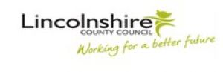Presentation by - Scott
The Special Educational Needs and Disabilities (SEND) Team at Lincolnshire County Council has embarked on an Employment project.
The project is aimed at embedding an employment pathway into our special school's existing Post-16 curriculum offer, which significantly increases young people's chances of obtaining paid employment upon leaving education.
The project aims to create opportunities; not only for our young people to enter the world of work but also for local businesses to develop and grow themselves in breaking down barriers associated with disability. They are working with schools to develop realistic and aspirational pathways for our young people to follow as they prepare for adulthood.
In addition, a SEND Employers Forum has also been created to develop a support network for employers, educators and other key stakeholders to benefit young people with additional needs across the county. The Forum is an opportunity to discuss and overcome challenges, explore new and innovative ways of working, drawing upon the skills and expertise around the table to promote and increase Supported Internships across Lincolnshire.
Contact(s):- Scott / Email:- scott.eley@lincolnshire.gov.uk Tel:- 07557 214082
Lincolnshire Parent Carer Forum
Presentation by - John
Lincolnshire Parent Carer Forum is the official independent parent carer forum in our county and represents parents and carers of family members with disabilities and Special Educational Needs (SEN).
We are tasked by the Department for Education in the SEND Code of Practice(2015) to work alongside Education, Health & Care to help improve the quality , range and accessibility of services. We host coffee mornings and events around the County.
Please see our website events page for more information.
We are always on the look out for volunteers to help with our work.
Email:- admin@lincspcf.org.uk Mob:- 07925 232466 Web:- www.lincspcf.org.uk
Lincolnshire Young Voices
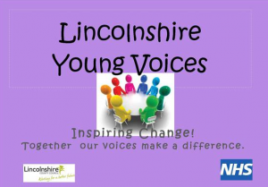Presentation by - Jo & Emma
Lincolnshire Young Voices is a newly formed group of young people with Special Educational Needs and Disabilities (SEND) who provide a voice for young people in the county.
The group is aimed at young people with SEND aged 11-25 years.
Email:- LincolnshireYoungVoices@lincolnshire.gov.uk Web:- www.lincolnshire.gov.uk/youngvoices
NHS Lincolnshire Clinical Commissioning Groups (CCGS)
Presentation by - Russell
Russell Outen-Coe is the Designated Clinical Officer (DCO) for Special Educational Needs and Disability (SEND).
- He is representing Lincolnshire’s Clinical Commissioning Groups (CCGs) which are part of the National Health Service (NHS).
- There are 211 Clinical Commissioning Groups in England.
- The CCGs bring together your local Doctors (GPs) and other health professionals (like nurses and therapists) to plan, buy and oversee the quality of the health care services in your area.
- They aim to improve your health services and respond to the health needs of everyone in the area by including patients and the public when we make decisions.
- Children and young people with Special Educational Needs and Disability need really good support across Education, Health and Social Care to help them to be the best that they can be.
He is here to ask you some questions and listen to what you say, to help the NHS make positive decisions around your health services in the future.
Tel:- 01522 513355 ext. 5461
NHS Lincolnshire Community Health Services NHS Trust’s Children’s Therapy Services
Presentation by - Abi
Lincolnshire Community Health Services (LCHS) Children’s Therapy Service comprises Occupational Therapy, Physiotherapy and Speech and Language Therapy.
The service works across Lincolnshire with children and young people, aged 0-19, who have disabilities or speech and language problems.
It works with children and young people with varying degrees of need at universal, targeted and specialist level. Each service has its own commissioned referral criteria.
Web:- www.ulh.nhs.uk

Week of SEND 2021
Carers First
Presentation by - Marie
Carers FIRST is a charity who supports people who look after a relative or friend who could not manage without their help.
Delivers the Lincolnshire Carers Service in partnership with the Lincolnshire County Councils Service Centre.
Together they provide a wide range of services to carers across the County.
Tel:- 01522 782224 Web:- www.carersfirst.org.uk/lincolnshire
Everyone
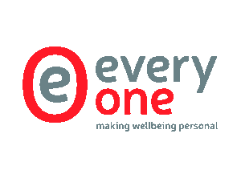Presentation by - Julie
Every-One were originally commissioned by Lincolnshire County Council through the Lincolnshire Health and Wellbeing Board to develop and establish a Carers Quality Standards Award. Continuation of funding through Lincolnshire County Council’s Better Care Fund has enabled the work to develop and the award has become a recognised symbol of quality.
The Carers Charter Quality Award ‘You Care – We Care’ ensures that the profile of unpaid carers in Lincolnshire is raised and the invaluable and essential contribution they make is recognised enabling carers to live fulfilling lives combined with their caring roles.
Undertaking the Lincolnshire Carers Quality Award to achieve the recognised quality award ‘You Care – We Care’ is a positive experience and strengthens organisational effectiveness and achieves recognition for the valuable way an organisation supports those carers with whom it works. It ensures the continuing development of quality approaches for those with caring responsibilities across Lincolnshire and beyond.
The Lincolnshire Carers Quality Award is going from strength to strength and numerous, wide and varied organisations are working towards accreditation and the request for and submission of applications grows weekly.
Lincolnshire Parent Carer Forum has received the Carers Quality award.
Email:- hello@every-one.org.uk Tel:- 01522 811582 Mob:- 07741572197 Web:- every-one.org.uk/
Family Fund
Presentation by - Elaine
Family Fund provides grants to families who are raising a disabled or seriously ill child aged 17 or under.
Their grants bring practical and essential help that is often a lifeline to a family such as washing machines, fridges, bedding, specialist toys and much needed family breaks.
They are a registered charity and the UK’s largest provider of grants to families living on low incomes who are raising disabled or seriously ill children.
To find out more or download an application form visit their website
Tel:- 01904 550055 Web:- www.familyfund.org.uk
LCC Independent Travel Training (ITT)
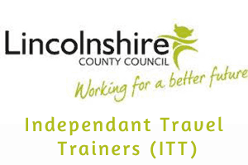Presentation by - Lynn
Is one-to-one training designed to equip young people who are entitled by Lincolnshire County Council to home to school or college transport with the confidence and skills required to travel independently.
ITT is facilitated by Independent Travel Trainers who will work closely with school/college staff, parents, carers and the trainees.
Anyone who is entitled to free home to school transport or Post 16 supported home to school/college transport is able to apply for Independent Travel Training.
Email:- ITT@lincolnshire.gov.uk Tel:- 01522 782020 Web:- https://www.lincolnshire.gov.uk/schools-and-education/school-and-college-transport/home-to-school-safety/90792.article
PAACT
Presentation by - Gordon
PAACT is a Lincolnshire-based support group for families with members who are on the autistic spectrum. We are run solely by volunteers and each committee member has a child or other family member with an autistic spectrum condition or is on the autistic spectrum themselves.
Our aim is to provide advice, support and signposting to anyone with queries or issues relating to autism and associated conditions. There is no requirement for a formal diagnosis in order to access this help.
We are a very friendly, informal and non-judgemental group and run our regular support group meetings on the same basis. In addition to these meetings, we have a Facebook group where parents and carers can share their ideas and thoughts.
During term time and holidays, we run regular activities for our younger members: there is a monthly games club, a weekly youth club plus holiday activities such as exclusive use of Fun Farm, bowling, crazy golf, pizza making... the list goes on!
We organise training for parents and professionals, including Makaton, behaviour and an introduction to ASC. We are also available in our Lincoln office between the hours of 10am and 2pm daily to offer support and guidance.
To find out more or get in touch
Email:- paactsupport@hotmail.co.uk Tel:- 01522 581915. Web:- www.paactsupport.com
Pelican Trust
Presentation by - Elaine
Pelican Trust Ltd. has been a strong part of the Lincoln community for nearly 30 years. Our services are greatly needed and appreciated in Lincoln and the surrounding areas which we hope to continue for years to come.
We have seen first hand what we can achieve with individuals who use our services and work alongside us. Through patience and perseverance their goals - however big or small - have been achieved at the Trust.
We strive to be an effective and supportive organisation providing meaningful work and training for people with mental health issues, physical disabilities and learning difficulties and disabilities.
Through our various departments and training we provide a service that helps individuals gain skills and confidence.
Contact(s):- Ms Pat Eastwood / Email:- pat@pelicantrust.org Tel:- 01522 513533 Web:- www.pelicantrust.org

Week of SEND 2021
Community Dental Services
Presentation by - Gina
Community Dental Services in Lincolnshire is a specialist dental provider for residents within the County (excluding North and North East Lincolnshire) with significant medical, physical or mental health disabilities, or people with severe dental anxiety. We are a referral only service, and our acceptance criteria and referral form can be found on our website.
They pride themselves on providing high quality care and treatment for children and adults whose dental care cannot be managed by a General Dental Practitioner. They accept referrals from all healthcare providers, however any referrals for dental anxiety reasons must come from a Dentist.
The Oral Health Improvement Team are part of the service co-ordinating, facilitating and supporting a range of evidence-based interventions to reduce oral health inequalities and promote better oral health.
Oral health is everyone’s responsibility; therefore, training is available to health and non- health professionals.
Sessions are tailored to meet the requirements of specific teams e.g. health visiting, teachers and many voluntary sector areas.
Email:- ohimp.lincolnshire@cds-cic.nhs.uk Web:- www.communitydentalservices.co.uk

Week of SEND 2021
Grantham & District Mencap
Presentation by - Charlotte
Formed by parents in 1970, Grantham & District Mencap Ltd provides Grantham based residential care and day support to people (18+) with learning disabilities and more complex needs.
Our team will assist you to manage your health and well-being needs and support you to make the most of your life through the activities that are provided to you.
Contact(s):- / Sue Crawford - Day Centre Manager Email:- sue.crawford@granthammencap.co.uk Tel:- 01476 566 050 Web:- www.granthammencap.co.uk
Healthwatch Lincolnshire
Presentation by - Julie
Healthwatch Lincolnshire is an Independent Champion for patients with any concerns relating to Health or Social Care.
All comments; positive or negative are collated and sent to the providers (no patient details are included.)
They also offer a signposting service should you not be aware of what to do, or where to go.
Email:- Info@healthwatchlincolnshire.co.uk Tel:- 01205 820892 Web:- www.healthwatchlincolnshire.co.uk
LCC ESCO
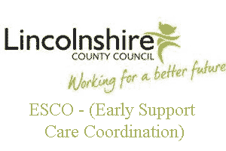Presentation by - Jo
ESCO is committed to improving the delivery of services for children and young people aged 0 - 18 years with significant and complex additional needs who require targeted coordination of services.
This can include:
- Children who have a greater difficulty communicating
- Have sensory or physical difficulties
- Complex health needs including those with a disability
- Babies leaving hospital with medical and other support needs
- Children with life-limiting conditions and palliative care
- Children with multiple and significant factors affecting their learning and development.
All need additional support during much of their daily lives and it is probable that there will be a long term impact on their development and learning.
ESCO keyworkers also offer support through drop-in appointments.
These provide the opportunity for parents/carers to meet with an ESCO Keyworker to discuss the available information, services and support in Lincolnshire.
ESCO offers a bookable one hour session at local Children’s Centres across Lincolnshire.
Parents/Carers can book a drop in appointment directly with Lincolnshire’s Customer Service Centre on:
01522 782 111
Email:- esco@lincolnshire.gov.uk Tel:- 01522 552 389
LCC The Working Together Team (WTT)
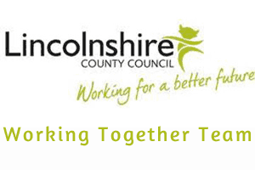Presentation by - Adele
Lincolnshire’s Autism, social communication SEND outreach service.
The Working Together Team (WTT) is a National Autistic Society (NAS) Accredited service, awarded the Professional Excellence Award in 2014 and Commended Practice December 2017.
Team members are skilled practitioners with specialist training and day-to-day hands on experience of working with youngsters with Autism, Social Communication and a wealth of special educational needs.
They offer high quality, specialist support for schools, academies, colleges and their families with children and young people, aged 4-19, with Autism, social communication needs
WTT provide expertise and practical specialised advice that enables schools to support children and young people to achieve the best possible social and educational outcomes and make the successful transitions to adulthood.
WTT can support the transition into Primary school from Nursery/pre-school (the summer term before entering school) and then further transitions up to college.
The team will support settings to identify the needs of the young person and work with staff and families in schools to tailor approaches to create specific programmes of intervention that they can implement.
Web:- http://website.twtt.org.uk
NHS Lincolnshire Community Health Services NHS Trust’s Children’s Therapy Services
Presentation by - Abi
Lincolnshire Community Health Services (LCHS) Children’s Therapy Service comprises Occupational Therapy, Physiotherapy and Speech and Language Therapy.
The service works across Lincolnshire with children and young people, aged 0-19, who have disabilities or speech and language problems.
It works with children and young people with varying degrees of need at universal, targeted and specialist level. Each service has its own commissioned referral criteria.
Web:- www.ulh.nhs.uk

Week of SEND 2021
LCC SEND team
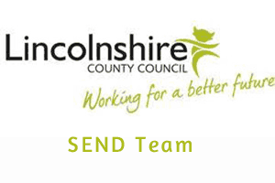Presentation by - The SEND Team
The SEND Team have experience with supporting families, children/young people with a varying degree of SEND that have required support and intervention above that which can be provided in an educational setting
Tel:- 01522 782030

Week of SEND 2021
Bridge House Independent School
Presentation by - Jade
Bridge House Independent School is a SEMH setting, with three schools based in Boston: the Grantham Road Campus, Carlton Road Campus and Great Fen Road Campus.
They pride themselves in supporting Key Stage 2, 3, 4 and 5 (7-18 years) pupils who disengage from education or (for whatever reason) find themselves outside of mainstream school.
They share the Government’s commitment in helping children achieve more and are fully committed to Safeguarding.
Email:- admin@bridgehouseindependentschool.co.uk Tel:- 01205 369111
Community Learning in Partnership (CLIP)
Presentation by - Katie
CLIP Community Learning in Partnership (CLIP) has a clear goal of widening participation in learning by people from rural, coastal and isolated communities.
They work, with equal commitment, with young people aged 16-18 years who have under-achieved at school and with adults who are looking to refresh their skills – for personal development, family, higher education or work. CLIP is also committed to supporting people who have experienced mental health difficulties. Through their Learning Minds project, they are developing a "recovery approach" through a series of courses on mental health and well-being.
CLIP now works with over 2000 learners a year and has over 40 staff and tutors. Most of their work is located in their community learning centres in Mablethorpe, Market Rasen and Gainsborough. Most of the programmes are publicly-funded and therefore open to quality inspection by Ofsted and other bodies. They were inspected in October 2017 gaining a Grade 2 - Good.
They have a wide range of opportunities available including:
• Study Programmes for 16-18s including work preparation, personal/social skills, Maths and English
• Community Learning for interest and personal development in a wide range of subjects, including Mental Health First Aid, Makaton and Introduction to Counselling
• ICT for beginners and improvers
• Accredited courses in a variety of vocational areas such as L2 Certificates in Understanding Autism, Mental Health Awareness and Counselling
• Job search and work-related skills for people looking for work
• English and Maths from Entry Level to GCSE
• Teacher training
Contact(s):- Katie Easey / Email:- katie@cliplearning.com Tel:- 01673 843489 Web:- www.cliplearning.com
Inclusion 21
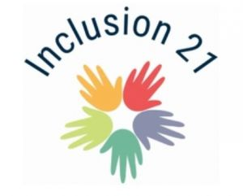Presentation by - Paul
Day centre for adults with Autism & Learning disabilities.
We are Lincoln's new Day Centre.
We are a privately run day centre for adults with Learning Disabilities and Autism, aged 18 and over. We provide person centred support within a safe and fun environment. We look to promote personal development, social and independent living skills in a setting where everyone and everybody feels welcome.
We're open Monday to Friday, 9am to 4pm, 49 weeks a year.
Activities we cover range from baking, sports, dance, arts & crafts, bowling, golf, nature walks, lift skills, discos, team building exercises, cinema trips, drama sessions and more!
We love our centre, and we are committed to ensure everybody who attends Inclusion21 loves it too.
If you have any questions, please don't hesitate to get in touch.
Contact(s):- Megan / Paul Email:- megan@inclusion21.co.uk: Paul@inclusion21.co.uk Mob:- 07469 828584 Web:- www.inclusion21.co.uk/
LCC Transitions
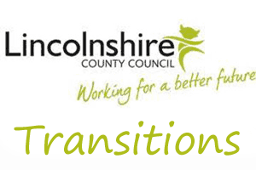Presentation by - Elita
Transitions Quality and Audit Officer
Quality and Standards Team Children Services Lincolnshire. County Council
I work in partnership with schools, colleges, as well as internal and external agencies , supporting children and young people with special educational needs and disabilities in transitions and preparing for adulthood.
Although I am not in a key-working role; I can offer information, advice and guidance on transitions planning in individual complex cases.
I attend parent evenings, open events and any parent carer events across the county. I sit on various working groups including the Local Offer, Autism Service Provision Group and the Children and Young People Operational Group for children and young people in care. I meet on a quarterly basis with Operational Leads of the colleges and Transitions Coordinators in the special schools.
My role also involves quality review and monitoring of the transitions planning process.
Contact(s):- Elita Cozens / Email:- Elita.Cozens@lincolnshire.gov.uk
LiNCHigher
Presentation by - Jonathan
Part of the Office for Students Uni Connect Project, LiNCHigher works with over forty schools, six colleges, two universities and a number of community groups across Lincolnshire, to break down barriers and obstacles for young people in accessing Higher Education.
Email:- linchigher.co.uk Web:- linchigher@bishopg.ac.uk
NRS Healthcare
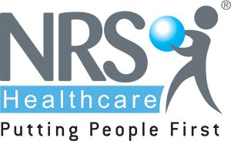Presentation by - Melanie
NRS Healthcare work in conjunction with Lincolnshire County Council to provide technology enabled care services across Lincolnshire.
They have a dedicated technology enabled care team including Occupational Therapists who can provide advice and support to parent carers. They can discuss specific situations with parent carers and their desired outcomes and requirements and help with the appropriate combination of equipment to meet these.
There is a technology enabled care website which parent carers can refer to www.nrstelecare.co.uk/lincolnshire which is supported by a dedicated helpline 01476 852492 (option 1).
Their team can also come and talk to groups about how technology enabled care can help their members.
Email:- customerservice@nrshealthcare.co.uk Tel:- 0345 121 8111 Web:- www.nrshealthcare.co.uk/

Week of SEND 2021
Healthwatch Lincolnshire
Presentation by - Tim - Learning Disability Health checks
Healthwatch Lincolnshire is an Independent Champion for patients with any concerns relating to Health or Social Care.
All comments; positive or negative are collated and sent to the providers (no patient details are included.)
They also offer a signposting service should you not be aware of what to do, or where to go.
Email:- Info@healthwatchlincolnshire.co.uk Tel:- 01205 820892 Web:- www.healthwatchlincolnshire.co.uk
Kids
Presentation by - Jade
KIDS is a national charity supporting disabled children, young people and their families.
Established in 1970, they work with thousands of families across the country each year, providing a wide range of services. They recognise that in order to support a disabled child, they must also support their family and through their services they aim to do that.
KIDS Positive Activities is a county wide service commissioned by Lincolnshire County Council to deliver fun sessions for children with disabilities age 5 -18 years.
Email:- Kids.lincolnshire@kids.org.uk Tel:- 01522 542937 Web:- www.kids.org.uk
LCC Dyslexia Outreach
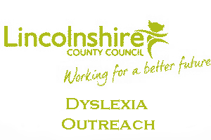Presentation by - Helen
Dyslexia Outreach is a county-wide service provided by Lincolnshire County Council. The team consists of two specialist teachers who have a wealth of expert knowledge and experience in teaching and supporting students with Dyslexia and literacy/maths difficulties, across the Primary and Secondary phases and beyond.
Dyslexia Outreach offer support, advice and training within schools. They also work closely with parents, supporting and advising through helpline and email contact, this is a free service for parents.
Reassurance and advice can be offered to help develop understanding of literacy and learning difficulties. This includes how to support to children to develop literacy and learning skills through home strategies, transition advice, signposting to other services and available resources
Contact(s):- Odette Read: North / Helen Lane: South Email:- odette.read@lincolnshire.gov.uk : helen.lane@lincolnshire.gov.uk Tel:- 07778 534478 (Odette) Mob:- 07823 535473 (Helen)
Travel Counsellors
Presentation by - Sheila
Expert travel planners, who help tailor and book your perfect holiday
The service is also focused on making the world accessible to people of all abilities.
With a level of personal experience you can be confident that I will understand your needs and provide a specialist travel service that is second to none. Whatever your additional access, mobility, sensory or cognitive requirements might be... and wherever in the world you wish to go
Contact(s):- Sheila Stamp / Email:- sheila.stamp@travelcounsellors.com Tel:- 01522 719190 Web:- www.travelcounsellors.co.uk

Week of SEND 2021
Jan Hargrave (Specialist)
Presentation by - Jan
Retired specialist in talking to children about relationships and sexual health.
Specialising in sexual health for children with SEND.
Exploring the often difficult and challenging issue of how parents of a child with SEND can manage and support their child through adolescence.

Week of SEND 2021
Liaise
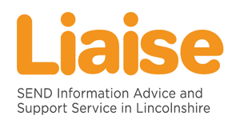Presentation by - Becky & Tracy
Liaise is the Special Educational Needs and Disability (SEND) Information Advice and Support Service for Lincolnshire.
They provide information and advice relating to SEN and disabilities to parents, children and young people which is free, confidential and impartial.
This can include help with understanding SEND law, local SEN and disability policy and procedures, support in schools and colleges, resolving disagreements, education, health and care plans, exclusions and admissions and personal budgets.
They provide initial help and support by telephone and email, and can allocate a Liaise Caseworker if further specific support is required.
Email:- liaise@lincolnshire.gov.uk. Tel:- 0800 195 1635

Week of SEND 2021
Healthy Minds
Presentation by - Sophie
Healthy Minds Lincolnshire provide support to children and young people 0-19 (25 if SEND or care leavers) on emotional wellbeing needs and building resilience through evidence based practice.
Their offer includes workshops, groups, accessible online content or up to 6 one-to-one sessions.
They are passionate about including parents and carers at every stage of intervention, as they know collaboration and holding the child at the centre is the key to success.
Contact(s):- Sophie / Mob:- 07966181541

Week of SEND 2021
Bid Services Lincolnshire
Presentation by - Angela - Employment coach
Are a charity that work in partnership with children, young people, adults and their families and carers. They support people who are deaf, hard of hearing, visually impaired or have a dual sensory loss.
Bid Services run activities throughout Lincolnshire called Chance to Meets for families with children with sensory impairments. These events given families an opportunity to meet, socialise and share experiences. Activities include sports events, bowling, music sessions and sensory activities at local parks and nature reserves and much more!
They also have a specialist care and support service to help children, young people and adults with a sensory loss to maintain their independence and improve their lives. They have a team of support workers trained in Deaf and Visual Awareness, BSL and Deafblind communication and sighted guide.
BID services also has as an employment coach for people with sensory impairment.
Contact(s):- Jorja / Angela (employment coach) Email:- support@bidlincs.org.uk Tel:- 01522 848295 Mob:- 07702939170 & 07783809801 Web:- www.bidlincs.org.uk
Home from Home Care
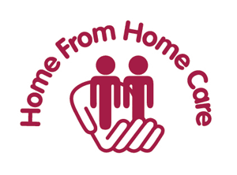Presentation by - Anna
Created by Parents to Make the Difference; Home from Home Care provides specialist residential care to adults (18+) with learning disabilities and complex needs, including autism, epilepsy, cerebral palsy, profound and multiple learning disabilities (PMLD), sensory impairment and associated health and mental health needs.
They support and encourage individuals to lead a fulfilled life through active days and meaningful activities.
Email:- getintouch@homefromhomecare.com Tel:- 0800 587 0372 Web:- www.homefromhomecare.com
LCC Young Peoples Learning Provision
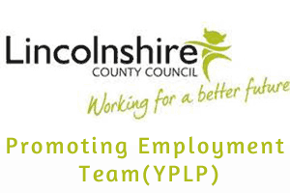Presentation by - James
The Young People’s Learning Provision (YPLP) offers alternative education to any young person aged 16-19, or to age 24 if you have an Education, Health and Care Plan (EHCP).
They work at seven different sites around the county: Boston, Grantham, Lincoln, Louth, Market Deeping, Skegness and Spalding. Young people come to them for lots of reasons, but all seeking the same thing - something a bit different, that offers support in the transition between education and adulthood.
They work at your pace, as quickly or as slowly as you need to go, and provide you with all you need to take those next steps - whether into employment, onto an apprenticeship, or into further education. With teachers, support workers, employment officers and job coaches, you will be well supported in every area of our work-based study programmes. Your time will be spent improving your level of English and maths if needed, alongside gaining qualifications in ICT and Employability-related subjects. You will also follow your own individualised programme of study designed around your needs and focusing on the skills needed for Adulthood, such as, employability, communication skills, team work, independent living skills, community inclusion and so much more.
Email:- yplp@lincolnshire.gov.uk Tel:- 01476 592169
Linkage Community Trust
Presentation by - Sarah
Linkage Community Trust is a charity delivering high-quality specialist education, day services, care, employment and support services for people with learning disabilities.
Their vision is that people with learning difficulties and disabilities have opportunities and choice, and are supported to achieve their aspirations.
They support and encourage individuals to make decisions about their own lives and enable them to develop skills and behaviours to live the life they choose based on their talents and abilities.
Email:- transition@linkage.org.uk Tel:- 01472 372310/372303 Web:- www.linkage.org.uk
Penderels Trust
Presentation by - Tammy
Penderels Trust is a charity providing direct payment support services to adults and children with disabilities and long term health conditions.
They provide these services under contract to Lincolnshire County Council. Their friendly and experienced independent living advisers in the Lincolnshire team work with many families with children with disabilities in the county.
A direct payment can make a real difference to a family and doesn’t need to be complicated. They will support you from the very start, making sure your family gets the most from your care and support package, with the peace of mind that we are always there to support you if you need them.
Email:- lincolnshire@penderelstrust.org.uk Tel:- 01526 833803 Web:- www.penderelstrust.org.uk Twitter:- www.twitter.com/the_pttp

Week of SEND 2021
County Care Independent Living Ltd
Presentation by - Helena
County Care is widely regarded as one of the most respected, innovative providers of support for people with learning disabilities, autism and mental health throughout Lincolnshire , Surrey, and West Sussex.
They are committed to providing high quality, person centred services which promote the independence, choice and inclusion of the people they support.
They have an excellent track record for the delivery of services which are truly personalised.
The services provided are
Day Services Monday – Friday 9am – 4pm at their centres in Holbeach and Skegness
Registered with the Care Quality Commission –
Support in the community for Children and Younger Adults
Head Office is situated in Skegness.
Email:- info@countycare.co.uk Tel:- 01754 611153 Web:- www.countycare.co.uk/
LCC Children with Disabilities Social Work Team
Presentation by - Sonia - Adults Social Care
Lincolnshire County Council’s Children with Disabilities Team are part of the Special Education Need and Disability Service.
The social work team provides a statutory service for children and young people with a severe and profound disability.
Services may be available to those that are eligible after being subject of a social care assessment.
Tel:- 01522 782111
LCC SEND Employment Project (Employers forum)
Presentation by - Scott
The Special Educational Needs and Disabilities (SEND) Team at Lincolnshire County Council has embarked on an Employment project.
The project is aimed at embedding an employment pathway into our special school's existing Post-16 curriculum offer, which significantly increases young people's chances of obtaining paid employment upon leaving education.
The project aims to create opportunities; not only for our young people to enter the world of work but also for local businesses to develop and grow themselves in breaking down barriers associated with disability. They are working with schools to develop realistic and aspirational pathways for our young people to follow as they prepare for adulthood.
In addition, a SEND Employers Forum has also been created to develop a support network for employers, educators and other key stakeholders to benefit young people with additional needs across the county. The Forum is an opportunity to discuss and overcome challenges, explore new and innovative ways of working, drawing upon the skills and expertise around the table to promote and increase Supported Internships across Lincolnshire.
Contact(s):- Scott / Email:- scott.eley@lincolnshire.gov.uk Tel:- 07557 214082
Lincolnshire Sensory Services
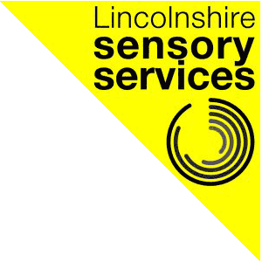Presentation by - Amanda
Lincolnshire Sensory services provides specialist services for anyone in Lincolnshire living with sight and/or hearing loss.
They understand the practical and emotional challenges that people with sensory loss can face in their everyday lives and, through their work, they focus on promoting independence, wellbeing and accessibility.
They aim to help people maintain independence and dignity in every aspect of their lives.
They also work closely with carers families and other professionals to increase their understanding of the impact of sensory loss and to assist them to build a wide network of support
Email:- contact@lincolnshiresensoryservices.org.uk. Tel:- 03333 202667 Web:- www.lincolnshiresensoryservices.org.uk/
Lincolnshire Wolds Community Trust - The Avenue
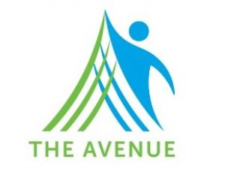Presentation by - Anita
Offers personalised day services for young people with complex needs, to develop skills around independence, communication, through ensuring they have a voice and choice, to work on their aspirations. Their vision is to ensure that each individual is supported to make decisions about their lives based around areas of interest and strengths.
Community inclusion activities play a large role within the offer.
Email:- marketing@lwf.lincs.sch.uk Web:- www.lwctrust.co.uk/
Lincolnshire Young Voices
Presentation by - Jo & Emma
Lincolnshire Young Voices is a newly formed group of young people with Special Educational Needs and Disabilities (SEND) who provide a voice for young people in the county.
The group is aimed at young people with SEND aged 11-25 years.
Email:- LincolnshireYoungVoices@lincolnshire.gov.uk Web:- www.lincolnshire.gov.uk/youngvoices

Week of SEND 2021
Carers First
Presentation by - Brian - benefits advisor
Carers FIRST is a charity who supports people who look after a relative or friend who could not manage without their help.
Delivers the Lincolnshire Carers Service in partnership with the Lincolnshire County Councils Service Centre.
Together they provide a wide range of services to carers across the County.
Tel:- 01522 782224 Web:- www.carersfirst.org.uk/lincolnshire

